**Prepared By: -**

**Jainish Trivedi(221263116015)**

**8th Semester IT**

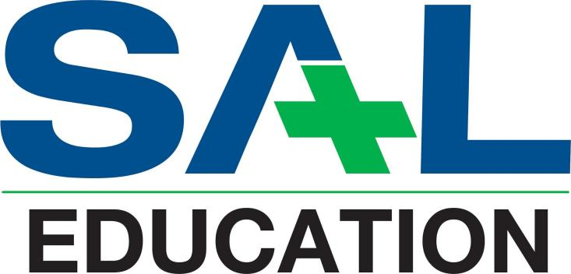

***SAL Engineering and Technical Institute***

***CE/IT/CSE/ICT Department***

**GTU 100 POINT FILE**

**Academic Year: 2024-25**

**INDEX OF CERTIFICATE**

**Teaching Activities**

|  |  |  |  |  |
| --- | --- | --- | --- | --- |
| **Sr. No** | **Name of Activity** | **Type of Activity** | **Month-Year of Activity**  **(Ex- Jan-2022)** | **Certificate Issued By** |
| **1** | React js workshop | Workshop | Jun - 2024 | SAL Engineering and Technical Institute |
| **2** | JAVA | Mooc course | Sep - 2024 | Coursera |
| **3** | Python Programming | Seminar | Dec - 2023 | SAL Engineering and Technical Institute |

**Sports Activities**

|  |  |  |  |  |  |
| --- | --- | --- | --- | --- | --- |
| **Sr. No** | **Name of Activity** | **Type of Sports** | **Level** | **Month-Year of Activity**  **(Ex- Jan-2022)** | **Certificate Issued By** |
| **1** | Cricket Tournament | Cricket | College | Jun - 2024 | SAL Engineering and Technical Institute |
| **2** | Chess Tournament | Chess | Zonal | Sep - 2024 | GTU |
| **3** | Table Tennis | Table Tennis | State | Dec - 2024 | GTU |
| **4** | Volleyball Tournament | Volleyball | National | Jan - 2024 | AICTE |

**Cultural Activities**

|  |  |  |  |  |  |
| --- | --- | --- | --- | --- | --- |
| **Sr. No** | **Name of Activity** | **Type of Activity** | **Level** | **Month-Year of Activity**  **(Ex- Jan-2022)** | **Certificate Issued By** |
| **1** | Singing | Singing | College | Jun - 2024 | SAL Engineering and Technical Institute |
| **2** | Photography | Photography | Zonal | Sep - 2024 | GTU |
| **3** | Dance | Dance | State | Dec - 2024 | GTU |
| **4** | Mimicry | Mimicry | National | Jan - 2024 | AICTE |

**Other Activities**

|  |  |  |  |  |  |
| --- | --- | --- | --- | --- | --- |
| **Sr. No** | **Name of Activity** | **Type of Activity** | **Level** | **Month-Year of Activity**  **(Ex- Jan-2022)** | **Certificate Issued By** |
| **1** | Tiranga Yatra | Community Service | College | Jun - 2023 | SAL Engineering and Technical Institute |
| **2** | Fuel  Conservation Pledge | Community Outreach | Zonal | Sep - 2024 | GTU |
| **3** | Tree Plantation | Community Service | State | Dec - 2023 | GTU |
| **4** | Swachh Bharat Abhiyan | Community Outreach | National | Jan - 2024 | AICTE |

* **IN LAST ATTACH POINTS TABLE FROM GTU 100 POINTS PORTAL HOME PAGE (MANDATORY).**
* **ALL CERTIFICATE IN HARD COPY AS PER ABOVE SEQUENCE.**